**COURSE REPORT**

**(SEM II)**

Submitted in partial fulfilment of the requirements

Of the degree of

BACHELOR OF ENGINEERING

In

INFORMATION TECHNOLOGY

By

**Name: Divya Shah**

**SE Roll No**.:**102**



Information Technology Department

Thadomal Shahani Engineering College

University of Mumbai

2019-2020

**CERTIFICATE**

This is to certify that the “Internship report” submitted by **Divya Shah, (Roll. No.: 102**) is work done by him/her and submitted during 2021 – 2022 academic year, in partial fulfilment of the requirements for the award of the degree of **“BACHELOR of ENGINEERING”** in **“INFORMATION TECHNOLOGY”**, Thadomal Shahani Engineering College.

Department Internship Coordinator

Dr. Shanthi Therese S. Dr. Shachi Natu

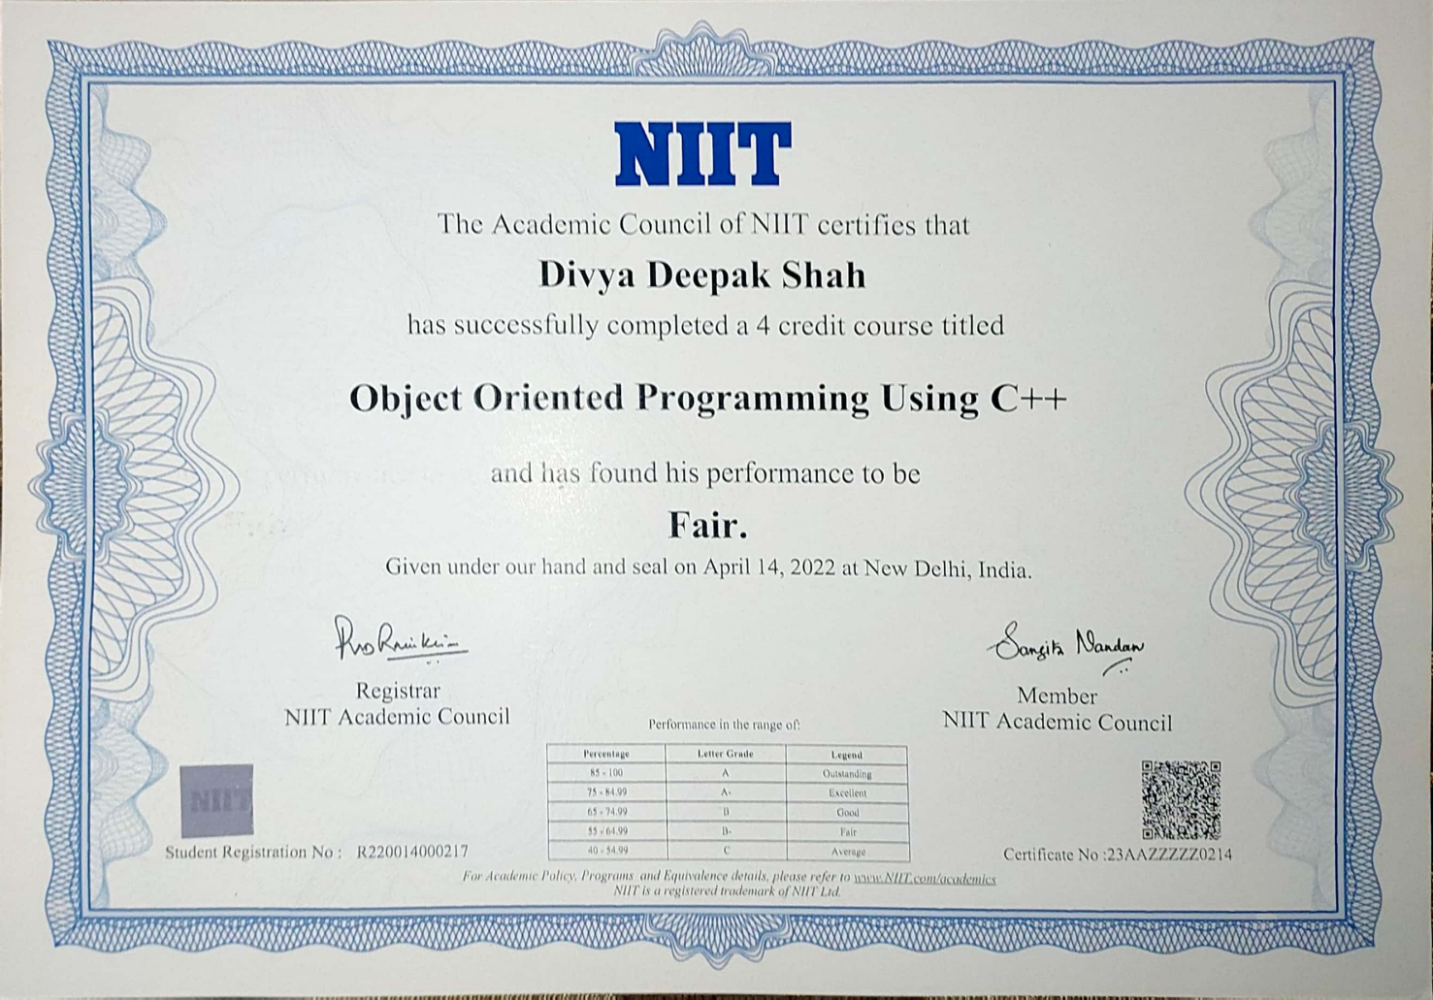

**ACKNOWLEDGEMENT**

The preparation of such a descriptive report cannot be accomplished only by one’s

own effort. I warmly acknowledge all the association offered to me during my

preparation of this report.

I would like to thank NIIT for this opportunity where I was able to find perfect course

for acquiring skills and my convenience even in this pandemic situation. I would also

like to thank my college Thadomal Shahani Engineering College for always inspiring

me to get familiar with information technology world by doing courses.

I would like to express my gratitude towards Gurunath A Kadam my Teacher for

teaching and for guiding me in this journey. Due to his kind help I was able to finish

my course and the other team members for cooperating and always motivating.

**ABSTRACT**

***About Company:***

NIIT is a multinational education-oriented organization focused on information and

computer technology and its headquarters in Gurgaon, India. It is primarily known for

its IT training but also offers corporate IT solutions. It is among India’s top providers

of computer education.

It also offers training for IT certification, including CCNA & NET certification, Java

certification., etc. NIIT is classified in India on both the NSE (National Stock

Exchange) & BSE (Bombay Stock Exchange).

***The Problem/Opportunity:***

I found myself sifting through large amounts of information trying to find the best

solution for this problem, therefore some aspects of it are not yet fully developed. In

the next chapter you will find more deeper explanation of how I went about

suggesting the above solution.

***Methodology:***

OBJECT ORIENTED PROGRAMMING was the main objective of course.

To develop a gaming application or software there are several object oriented

programming languages that are in use.

Some of them are only used for the frontend and backend design of the software.

Learning in NIIT really added huge knowledge in my upcoming career.

Solving real life problems was another key issue. This report takes us through all the

details of OBJECT ORIENTED PROGRAMMING knowledge and experience

gathered during this internship period.

***Benefits to the company/institution through your report:***

The company can be benefitted in the future by my report to see how it motivated

me to learn about handling complex codes in a company which would help me in

future for Developing games and other application.

**INDEX**

|  |  |  |
| --- | --- | --- |
| **SR. NO.** | **CONTENTS** | **PAGE NO.** |
| **1.** | Learning Objectives |  |
| **2.** | Weekly overview of course activities |  |
| **3.** | Introduction |  |
| **4.** | Internship Discussion |  |
| **5.** | Conclusion |  |
| **6.** | Bibliography |  |

**OBJECTIVE**

The objective of learning the course is that it will help me brush up my programming skills and also learn new concepts in I.T world.

The C++ language has best garbage collector making programming fast. The system

contains database where all the information will be stored safely.

OOP stands for Object-Oriented Programming.

The objective of learning the course is that it will help me brush up my programming skills and also learn new concepts in I.T world.

The objectives of object oriented programming course is as follow:

1. ***To save the time and resources:***

The C++ programming language takes less time in entering the data, processing it and getting its output.

1. ***To make the system user friendly:***

The system will be much more easy to use and the operator will feel no difficulty.

**WEEKLY OVERVIEW OF COURSE ACTIVITIES**

|  |  |  |  |
| --- | --- | --- | --- |
| **Week #1** | **Date** | **Day** | **Name of the topic /Module** |
| 19 January, 2022 | 01 | What is programming, application of different types programming, basics of C++ |
| 20 January, 2022 | 02 | Variables, header files, data types |
| 21 January, 2022 | 03 | String data type and its application |
| 22 January, 2022 | 04 | Local and Global variables and pointers |

**WEEKLY OVERVIEW OF INTERNSHIP ACTIVITIES: WEEK 2**

|  |  |  |  |
| --- | --- | --- | --- |
| **Week #2** | **Date** | **Day** | **Name of the topic /Module** |
| 23 January, 2022 | 05 | Operators, Insertion Operators, Arithmetic operators and Logical Operators. |
| 24 January, 2022 | 06 | Access Modifiers, Bitwise Operator and Conditional Operators |
| 25 January, 2022 | 07 | Conditional statements consisting of for loop, while loop, do while loop, switch case, and go to |
| 26 January, 2022 | 08 | Nested loops and Arrays |

**WEEKLY OVERVIEW OF INTERNSHIP ACTIVITIES: WEEK 3**

|  |  |  |  |
| --- | --- | --- | --- |
| **Week #3** | **Date** | **Day** | **Name of the topic /Module** |
| 27 January, 2022 | 09 | Function, Recursive function, and Passing of parameters in function |
| 28 January, 2022 | 10 | Call by Function,  Call by parameters |
| 29 January, 2022 | 11 | Call By Value and Call By Reference |
| 30 January, 2022 | 12 | Object oriented programming basics |

**WEEKLY OVERVIEW OF INTERNSHIP ACTIVITIES: WEEK 4**

|  |  |  |  |
| --- | --- | --- | --- |
| **Week #4** | **Date** | **Day** | **Name of the topic /Module** |
| 30 January, 2022 | 13 | Classes and Objects |
| 31 January, 2022 | 14 | Classes and Objects continued |
| 1 February, 2022 | 15 | Structure and union |
| 2 February, 2022 | 16 | Classes types (public, private, protected .) |

**WEEKLY OVERVIEW OF INTERNSHIP ACTIVITIES: WEEK 5**

|  |  |  |  |
| --- | --- | --- | --- |
| **Week #5** | **Date** | **Day** | **Name of the topic /Module** |
| 3 February, 2022 | 17 | Inheritance, Multilevel and Multiple Inheritance |
| 4 February, 2022 | 18 | Encapsulation (public, private, protected) |
| 5 February, 2022 | 19 | Polymorphism, Access specifier |
| 6 February, 2022 | 20 | Student Management System |

**INTRODUCTION**

As a full time student at University of Mumbai I have decided to undertake a

semester of my second year studies at Thadomal Shahani Engineering College. The

degree towards I am currently studying is a Bachelor of Engineering.

In my course program, firstly the programming languages and development tools

I was using at the class were new for me, hence I had to quickly integrate not only

with my new living environment but also academically. This was very beneficial for

me as at the end I could compare what I’ve learnt with what I already new and find

a connection between the two.

Since I find myself more interested in the area of coding, I was going in right path

into coding journey.

This report is a description of my 5week course carried out in NIIT.

**COURSE DISCUSSION**

The course of object oriented programming was very helpful since C++ Language is

very fast programming language and also it is used in making games such as Counter

Strike, Doom III and also Football pro.

***About Course Work:***

1. Develop a logical understanding using software tools and also learn about object oriented

concepts of inheritance, encapsulation and overloading.

2. Share daily work status report with teacher and if any issue arising, straight a way

coordinating with teacher.

1. Doing regular practise during course to increase the level of understanding.

***Motivation:***

In class we created student management system which is easy to understand. Since I

enrolled in this course it seemed to me that I am beginner and primary level to learn

programming, and competitive coding.

Further related mini assignment of student which I worked on introduced me to data

base and also structured query language.

Its technology is so interested and charming and easy to build a project by fully C++.

***Task Assigned:***

1. To create calculator using C++ language.
2. To create student management system

***Learning Outcomes***

1. To describe the advantages of a high level language like C/C++, the programming process, and the compilation process.

* Describe and compare machine language and a high level language
* Discuss the advantages of a high-level language
* Distinguish between source code, object code and executable code
* Describe the function of the compiler in the language translation process

1. To describe and use software tools in the programming process

* Describe the functions of an IDE
* Use an IDE to compile, load, save, and debug a C/C++ program

1. To apply good programming principles to the design and implementation of C/C++ programs

* Demonstrate an understanding of algorithms in the problem-solving process
* Identify the necessary properties of good problem-solving techniques
* Create and analyze algorithms for solving simple problems
* Use incremental program development to create, test, and debug algorithms for solving simple problems
* Write readable code that follows accepted style and documentation guidelines
* Apply techniques of structured (functional) decomposition to decompose problem

and a program solution into smaller pieces

* Create and call functions that use parameter passing and return values
* Design and implement code that includes the reuse of both existing code and

calling functions in the C/C++ libraries

1. To design, implement, debug and test programs using the fundamental

elements of C/C++

* Demonstrate an understanding of the overall syntax and semantics of C/C++

programs by writing small programs from specifications given in class

* Describe the fundamental components of a C/C++ program (e.g.,. source files, header files, main() function, functions, and libraries)
* Explain and apply fundamental syntax rules for identifiers, declarations, expressions, statements, and functions
* Demonstrate an understanding of scope, lifetime and duration rules for variables and functions
* Analyze, explain and trace the behavior of simple programs involving the fundamental programming constructs addressed in the course
* Modify and extend short programs that use standard conditional and iterative control structures and functions
* Write programs that use each of the following fundamental programming constructs: basic computations, simple console I/O, standard conditional and iterative structures (including pretest and posttest loops, counter-controlled loops, and conditionals)
* Choose appropriate conditional and iterative constructs for a given programming task
* Debug and test programs in order to determine that the program performs as expected: Demonstrate the ability to create test cases to determine that a solution produces expected outputs for given inputs
* Test user input for erroneous values

1. To demonstrate an understanding of primitive data types, values, operators and expressions in C/C++

* Discuss the representation and appropriate use of primitive data types
* Select appropriate primitive data types for solving a variety of problems (e.g.,,

integer, real, character and string data)

* Demonstrate the use of arithmetic and relational operators including operator

precedence and the use of parentheses

* Describe automatic type conversion rules, related issues of magnitude and

precision, type casting, and determine the value and type of an expression involving mixed types

* Demonstrate the use of numeric arrays and c-style strings
* Trace the execution of source code containing pointers

*How was objective achieved?*

The course object oriented programming helped me in learning and clearing many concepts of object oriented programming concepts (OOPs), and also helped in learning competitive coding.

**CONCLUSION**

As a conclusion, I can say that this course was a great experience. Thanks to this

course, I acquired deeper knowledge concerning my technical skills but I also

personally benefited. C++ programming us the base for programming language which

is part creating of applications, and one of the most popular language for application

creation used by developers worldwide. I learn to live in a different environment from

the one I am used to. Indeed, I grew more independent in work and also in everyday

life. I realized that I could do more things than I thought like learning new things by

myself.

There are huge opportunities available for the students who want to work in

this field. With the rapid advent of online industry, the demand of app creation in

professional world is increasing and this has created a huge job opportunity for the

aspirants in the upcoming days. Also an experienced person in this field can also work

as a freelancer; there are many online companies which provide online projects to the

individuals.

**BIBLIOGRAPGHY**

[www.github.com](http://www.github.com)

[www.youtube.com](http://www.youtube.com)

[www.niit.com](http://www.niit.com)

[www.wikipedia.com](http://www.wikipedia.com)

[www.coursera.com](http://www.coursera.com)

[www.w3school.com](http://www.w3school.com)

[www.stackoverflow.com](http://www.stackoverflow.com)